**Software Requirements Specification (SRS):**

The document in this file is an annotated outline for specifying software requirements, adapted from the IEEE Guide to software Requirements Specifications (Std 830-1993).

A software requirements specification document describes the intended purpose, requirements and nature of a software to be developed. It also includes the yield and cost of the software.

In this document is about explaining the Operational and Requirement details of the Online Home Loan application.

**SOFTWARE REQUIREMENTS SPECIFICATION**

**Online Home Loan Application**

**Case Study by Group-5**

**Table of Contents**

**1.Introduction**

**1.1 Purpose**

**1.2 Scope**

**1.3 Definitions, Acronyms and Abbreviations**

**1.4 References**

**1.5 Overview**

**2.Overall Description**

**2.1 Product Perspective**

**2.2 Product Functions**

* **User Authentication**
* **Document Verification**
* **Save or View loan amount transaction history**
* **Loan Tracker**
* **Calculator**
* **Account Creation**

**2.3 User Characteristics**

**2.4 General Constraints**

* **Hardware Requirements**
* **Database**
* **Web-Based**

**2.5 Safety and Security**

**2.6 Assumptions and Dependencies**

**3.Specific Requirements**

* **3.1 Functional Requirements**
* **3.1.1 Login**
* **3.1.2 Calculator**
* **3.1.3 Loan Application**
* **3.1.4 Admin**
* **3.1.5 Loan Tracker**
* **3.2 External Interface Design**
* **3.3 Performance Requirements**
* **3.4 Design Constraints**
* **3.4.1 Standards Compliance**
* **3.4.2 Hardware Limitation**
* **3.5 Software System Attributes**
* **3.5.1 Reliability**
* **3.5.2 Availability**
* **3.5.3 Security**
* **3.5.4 Maintainability**
* **3.5.5 Portability**
* **3.6 Other Requirements**
* **3.6.1 Logical Database Requirements**

**4.UML Diagrams**

**1.** **INTRODUCTION**

We provide a hassle-free user-friendly online platform to our users through which they can apply for loans based on their own requirements and keep a track of their status and record during the entire process of their loan term without visiting any bank branch completely online.

**1.1 Purpose:**

* Availing loan is a very long and cumbersome process in India. The whole procedure of loan approval may take weeks or even months.
* Our system increases customer retention and simplifies loan and EMI management.
* Our project is designed to be used by any individual for a home loan.
* Our customers can view available services, policies, benefits and other information related to a specific loan.
* The system collects the required information about the individual and then verifies if they satisfy the eligibility criteria based on which the loan gets approved or rejected.
* We also provide features such as eligibility and Emi calculators through which users can get a rough estimate of the EMI and the loan Amount, they are eligible for.
* The current System is paper based System, which is somewhat difficult to manage.

**1.2 Scope:**

* You may use the money you receive to pay for material expenses for your loan.
* Sometimes repayment starts after a ‘moratorium period’.
* The Borrower must have a repayment strategy before EMIs start.
* The ongoing system is paper based System, which is very difficult to manage.
* It is user friendly GUI, anyone with little knowledge can easily operate it.

**1.3 Definitions, Acronyms, and Abbreviations:**

* **Definitions:**
* **‘Home Loan’** money borrowed to material requirement related expenses. Payments are often deferred according to the need of the customers.
* **‘EMI-Calculator’** the operation where an individual can calculate the Equated Monthly Installment amount for the Loan which he/she is getting.
* **‘Loan Tracking’** process that enables the applicant to follow up the Loan process.

* **List of Acronyms and Abbreviations:**
* SBI State Bank of India
* BOI Bank of India
* GDP Gross Domestic Product

**1.4 References:**

* Google.com
* Bank Websites
* Wikipedia.com

**1.5 Overview**

• User Login

• The Home loan System has mainly two entity they are:

**Admin and** **User Panel**

* Admin helps in the authorizing the loan process.
* Admin acts as the bridge between the customer and the parental branch.

•The system shows the user different loan schemes and plans, which the user can view and select plans accordingly.

•User fills in the required data.

•The system checks the user data and approves loans if eligibility criteria are satisfied.

•User can track his loan status in system after applying for loan.

•User data is stored as records which can be further used.

**2.Overall Description:**

**2.1Product Perspective:**

Following is the context or origin of online Home Loan management system. Comparison b/w the Tradition system and the new system can also be cleared through the system models.

Traditional Home Loan Management system

Fill Application Form

Bank Branch

Apply loan 5-6 hours waiting

Submit required document

Loan Approved

After implementing the loan management system, customers will be able to apply for a loan using our user-friendly online platform. Time usage will be minimized tasks will be done fast instead of waiting for someone else to complete their task.

Online Home Loan Management System

Less time Loan approved

Internet

Apply loan

**2.2 Product Functions:**

This Software will have following functionalities:

• **USER AUTHENTICATION**

Allows users to register themselves in our online portal and registered users can login.

• **DOCUMENT VERIFICATION:**

Users can upload all the required documents easily. After Successful completion of application process users will receive a unique application number and a document verification appointment date.

• **SAVE OR VIEW LOAN AMOUNT TRANSACTION HISTORY:**

The customer will be able to check the loan amount he paid and the remaining amount which he must pay in the given time period.

•**Loan Tracker:**

Users can track the status of their loan using their unique application id and their date of birth.

**•CALCULATOR:**

Using the calculator users can get a rough estimate of the EMI and the loan amount they are eligible for.

1. Eligibility Calculator:

By using our system eligibility calculator user can check the loan amount to which he is eligible for.

1. EMI calculator:

The EMI Calculator receives the loan amount and the loan tenure required keeping the interest rate constant at 8.5% and calculates the monthly EMI.

**•ACCOUNT CREATION**

Once Customer’s loan is approved an account is created by generating an account number and the loan amount is transferred to the customer account.

**2.3 User Characteristics:**

There are various kinds of users for the product. Usually, web products are visited by various users for different reasons. The users include:

* The admin will be acting as the controller, and he will have all the privileges about user information.
* Customers can apply online for loan.
* User can compare bank/financial Organizations and their interest rates.

**2.4 General Constraints:**

* **User Interface**

•GUI standards or product family style guides that are to be followed

•Screen layout or resolution constraints

•Standard buttons, functions, or navigation links that will appear on every screen such as a help button

•Error message display standards

**2.5 Safety and Security:**

This Project must be safe and secure because customers will directly contact Financial Organizations through internet for loan process. Software will have to identify the valid customer according to his/her details and password. So, it is a difficult task to protect the system from major disasters by preventing unauthorized access to the system.

**2.6 Assumptions and Dependencies:**

Following are the assumptions and dependencies which are related to this home loan project.

* This project is a stand-alone project so it will not affect the system where it will be embedded.
* This project is a web-based project while the staff was addict of using traditional methods of data storage and retrieval so they will be trained a bit to jump to it.
* This system will not depend on any other module. It will be web-based so everyone will independently contact it.
* It will not affect the environment at all.
* Financial Organizations will free adopt it because it will not be so much expensive.
* As this project contains valuable and new features so it will probably remove the online home loan systems embedded in some banks/financial Organizations.

# **3. Specific Requirements**

## **Functional Requirements**

**3.1.1 LOGIN:**

User - This field allows users to login with their application ID and password.

* Admin - This field allows authorized admin to login.

**3.1.2 CALCULATOR**

* Eligibility Calculator:

The eligibility calculator receives the user’s monthly income and shows the loan amount the user is eligible for using the following calculations:

Loan amount = 60 * (0.6 * net monthly salary)

* EMI calculator:

The EMI Calculator receives the loan amount and the loan tenure required keeping the interest rate constant at 8.5% and calculates the monthly EMI based on the following Calculations:

EMI = P*R*{((1+R) ^n)/((1+R) ^n-1)}

**3.1.3 LOAN APPLICATION:**

The application page has the following three sections

* **Income Details** -

It provides fields for income details such as property location,

Property name, estimated cost of property etc.

* **Loan Details** -

It provides files for loan details such as the amount required,

user’s monthly income, etc.

* **Personal Details** -

It takes details such as users name, age, DOB, Personal identification details such as Aadhar card, pan card no, etc.

* **Documents upload** -The user can upload digital scanned copies of the Aadhar card, pan card, collateral, etc.
* On completion of the above procedures, your application will be submitted for verification.

**3.1.4 ADMIN:**

* Verification of user data.

**3.1.5 LOAN TRACKER:**

You can track the current status of your loan as follows

* Sent for verification
* Verified and sent for final approval
* Approved/rejected

**3.2 External Interface Design :**

* Home
* Calculator
* Login
* Loan Application
* Features
* About Us
* FAQ
  1. **Performance Requirements**
* Response time should Be minimum.
* Any device Can support this with maximum speed.

## **3.4 Design Constraints**

* Database is managed in SQL Server.
* The system is Web based.

3.4.1 Standards Compliance:

* **Standards-compliance** is the **compliance** of a website or web browser with the web standards of the **World Wide Web Consortium** (W3C). To ensure interoperability, a standards-compliant web site does not use **proprietary software** methods or features of a browser.
* Current use of the term "standards-compliance" generally refers to the adherence to coding practices in relation to the use of [HTML](https://en.wikipedia.org/wiki/HTML)or [XHTML](https://en.wikipedia.org/wiki/XHTML), with [Cascading Style Sheets](https://en.wikipedia.org/wiki/Cascading_Style_Sheets) (CSS) to define the layout, colors, and fonts of a web page. The [Web Standards Project](https://en.wikipedia.org/wiki/Web_Standards_Project) (WaSP) is a group, mainly composed of experienced web developers, whose mission is to encourage the use of these standards globally.
* Their recent efforts have been to promote the use of and adherence to the CSS 2.0 web standard by browsers, including how browsers respond to invalid markup and styles. The tests developed by WaSP are called [Acid1](https://en.wikipedia.org/wiki/Acid1), [Acid2](https://en.wikipedia.org/wiki/Acid2), and [Acid3](https://en.wikipedia.org/wiki/Acid3), with each testing CSS1, CSS2, and CSS2+ (CSS2 + Client-Side Scripting), respectively.

3.4.2 System Requirements:

* Operating System - Windows 8 or higher.
* Processor - i3-5005U or higher.
* Speed - 1.0 GHz
* RAM - 2 GB or more
* Hard Drive - 6GB or more

## **3.5 Software System Attributes**

3.5.1 Reliability:

* Only authorized users can apply for loans.
* Any other user should register themselves through an online portal.

3.5.2 Availability:

* Available for every registered user.

### 3.5.3 Security:

* Allows authorized admin to check and verify the user data.
* Only authorized users can use the portal.
* Every user is given an application id and password.
* Database is checked for every set of id and password for authorizing the user.
* Does not contain bank information about the users.
* Any user with an application id and password can use this portal for loan tracking and eligibility.
* Passwords must be included with special characters.

3.5.4 Maintainability:

* Loan amounts and interest rates are updated if any new rule is added to the system.
* Any individual can apply for a loan and check for eligibility based on their requirement.

3.5.5 Portability:

* **Portability** in high-level computer programming is the usability of the same **software** in different environments. The pre-requirement for **portability** is the generalized abstraction between the application logic and system interfaces.
* Portability is a form of reusability. Some kinds of software are known to be less portable than others. An example of software that is not portable would-be assembly code, since assembly code is specific to processor type. No software is perfectly portable because all software has its own limitations.
* This is a website so any user can access this on any machine.

**Definitions of the quality characteristics not defined in the paragraphs above follow:**

### 

* **Adaptability:** This is defined by the ability of the software to be able to adapt to different, specified environments without providing any extra means other than those provided for this purpose.
* **Replace ability:** This is defined in terms of the ability of the software to be used in place of another specified product for the same purpose within the same environment.
* **Correctness:** Extent to which program satisfies specifications, fulfills user’s mission objectives.
* **Co-existence or compatibility:** This features the ability of a software to work with other independent software in a common environment and share the same resources.
* **Install ability:** Installation software is basically tested for its ability to successfully install the target software in the desired environment. This includes checking of free space, checking prerequisites, installation procedures, installation interruption, customization, initialization, and/or uninstall.
* **Efficiency:** Amount of computing resources and code required to perform function.
* **Flexibility:** Effort needed to modify operational program.
* **Interoperability:** Effort needed to couple one system with another.
* **Reliability:** Extent to which program performs with required precision.
* **Reusability:** Extent to which it can be reused in another application.
* **Testability:** Effort needed to test to ensure it performs as intended.
* **Usability:** Effort required to learn, operate, prepare input, and interpret output.

## **3.6 Other Requirements**

3.6.1 Logical Database Requirements:

* Database stores all the records of user.
* Database is used for maintaining the records.
* Database for comparing bank loans.

**4.UML Diagrams:**

**Use Case Diagrams:**

**Admin Side**

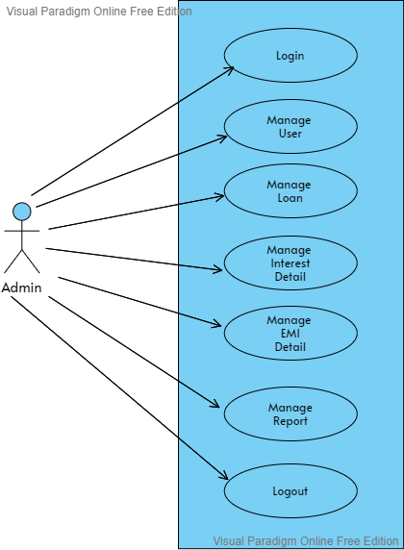

**Customers Side:**

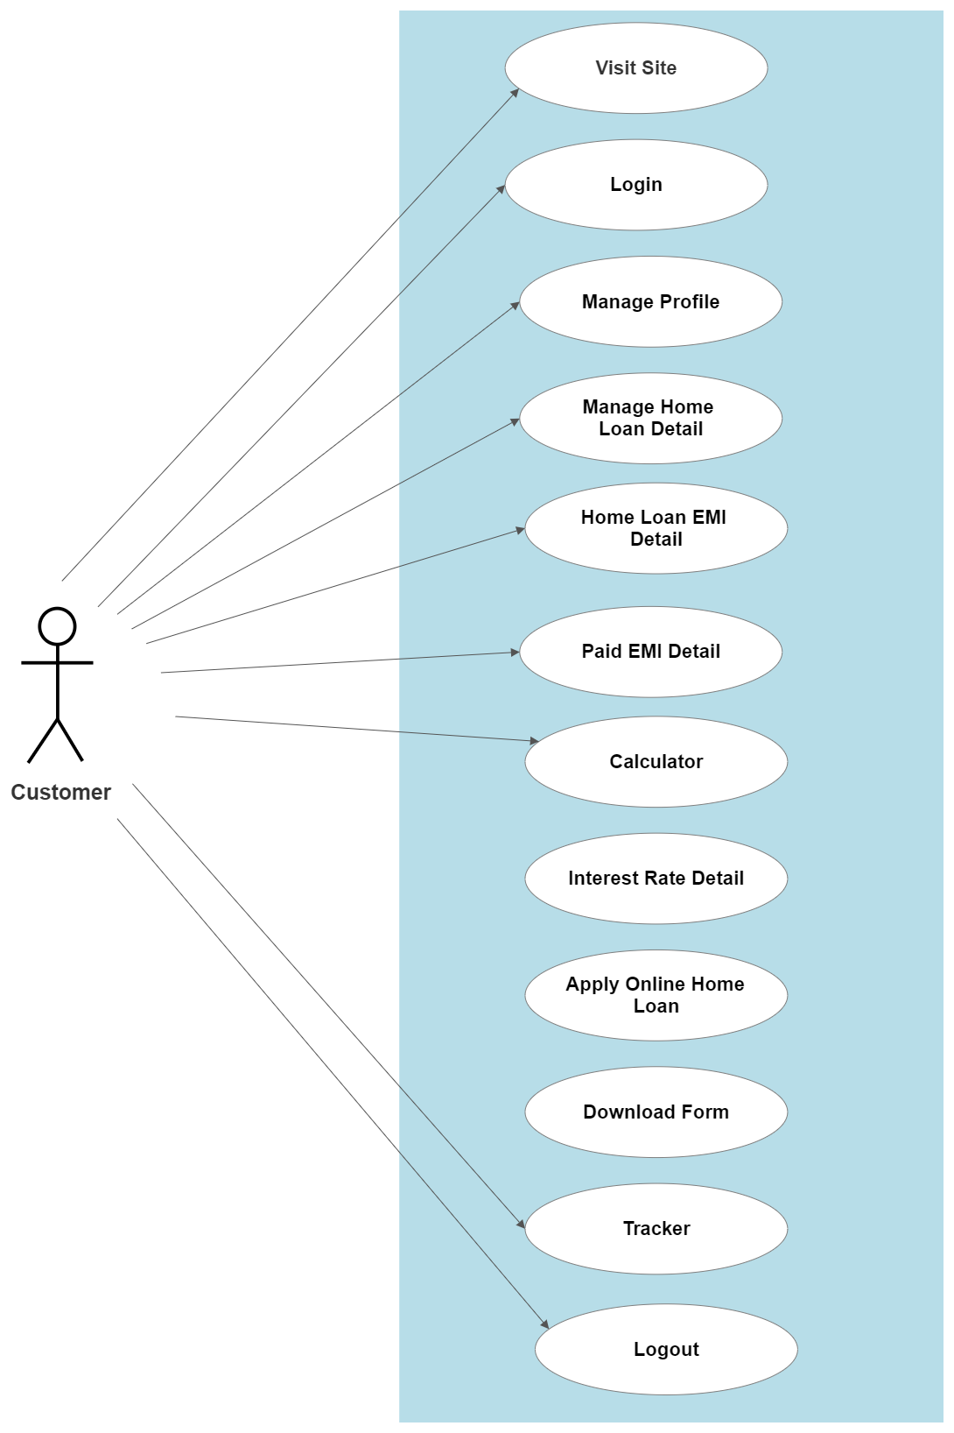

**Sequence Diagram:**

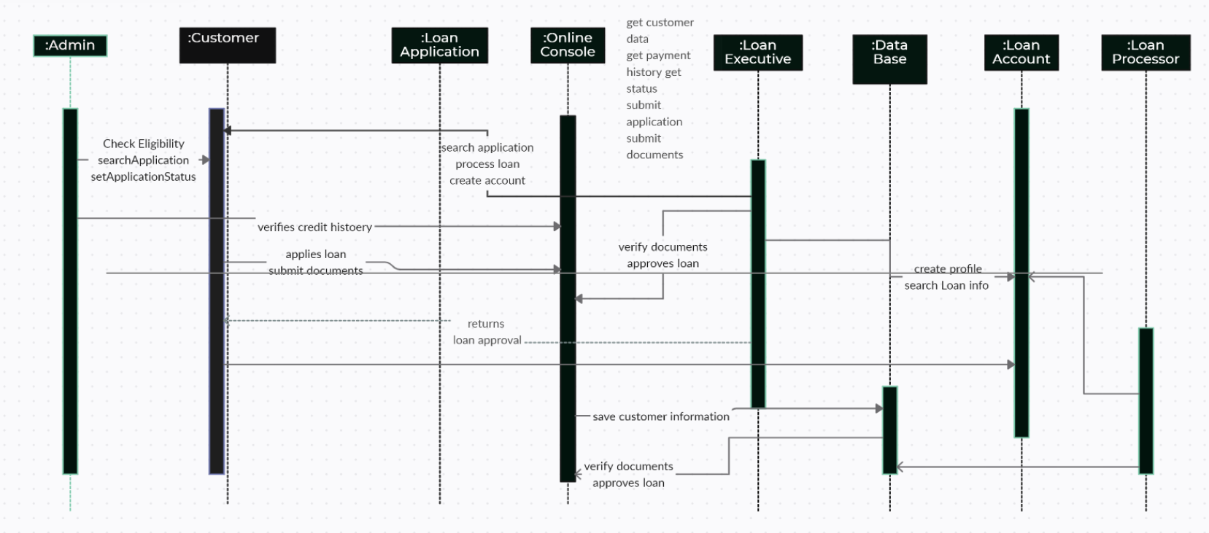

**Activity Diagram:**

**Admin Side:**

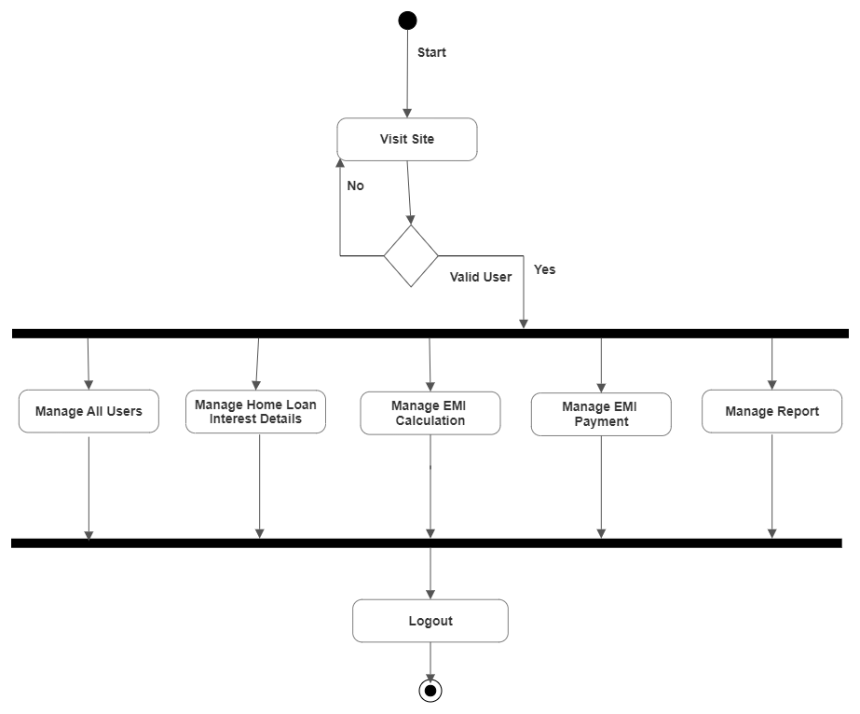

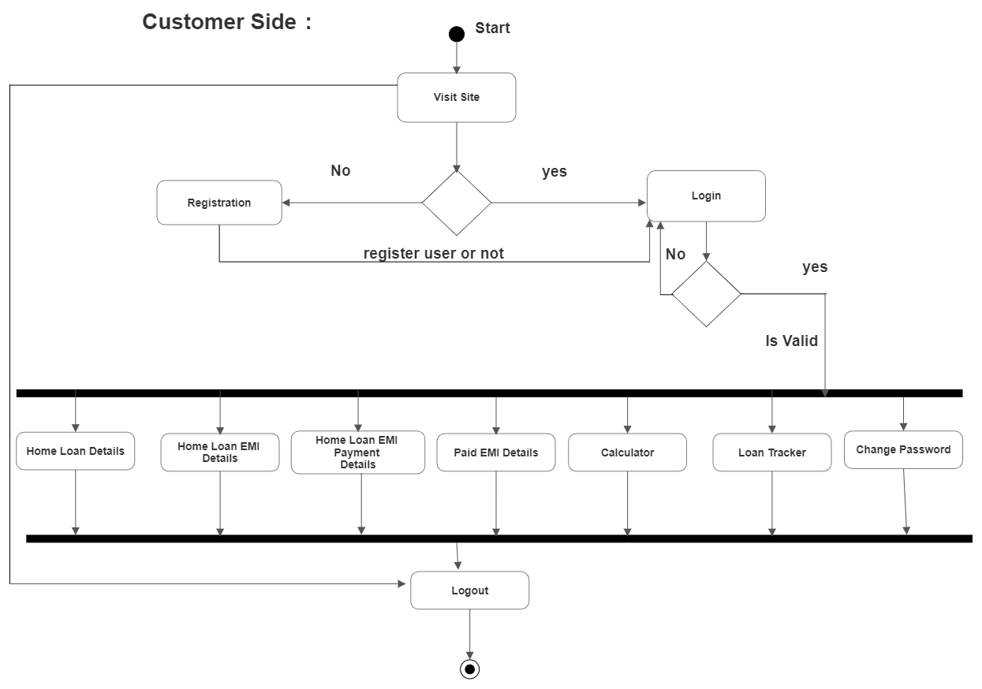

**ER Diagram:**

